Abdulelah Almubarak

9/15/2019

Activity 4A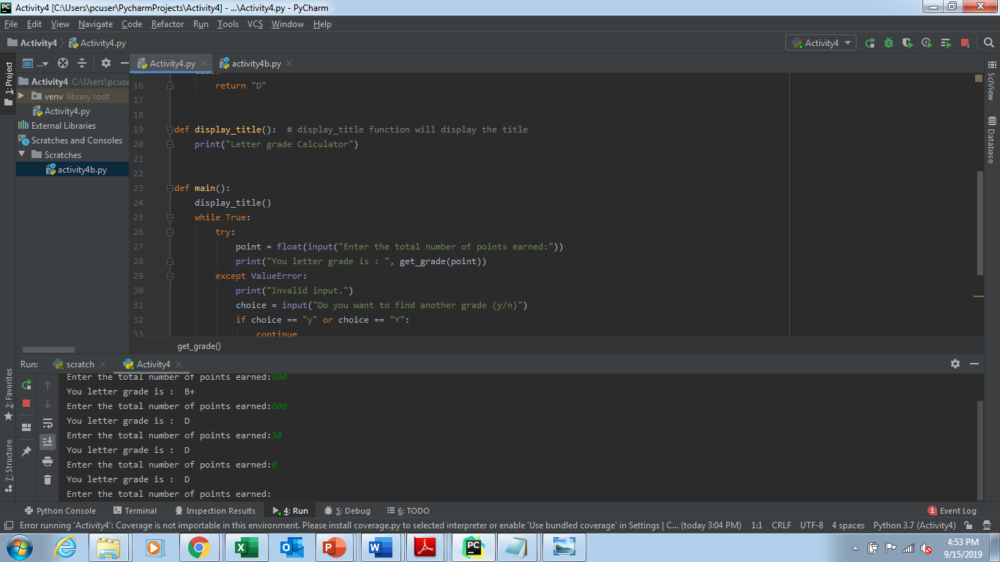

Activity4b

